**Database management systems**

# **Labsheet - 4**

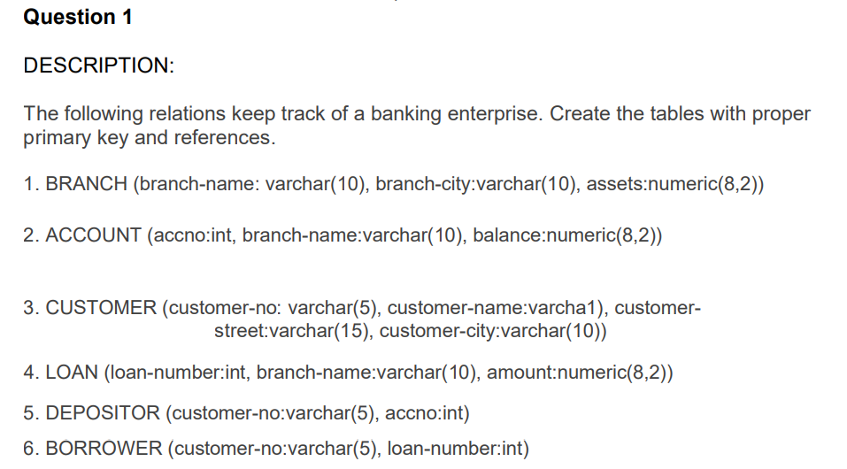

CREATE TABLE BRANCH (

branch_name VARCHAR(10) PRIMARY KEY,

branch_city VARCHAR(10),

assets NUMERIC(8,2)

);

CREATE TABLE ACCOUNT (

accno INT PRIMARY KEY,

branch_name VARCHAR(10),

balance NUMERIC(8,2),

FOREIGN KEY (branch_name) REFERENCES BRANCH(branch_name)

);

CREATE TABLE CUSTOMER (

customer_no VARCHAR(5) PRIMARY KEY,

customer_name VARCHAR(10),

customer_street VARCHAR(15),

customer_city VARCHAR(10)

);

CREATE TABLE LOAN (

loan_number INT PRIMARY KEY,

branch_name VARCHAR(10),

amount NUMERIC(8,2),

FOREIGN KEY (branch_name) REFERENCES BRANCH(branch_name)

);

CREATE TABLE DEPOSITOR (

customer_no VARCHAR(5),

accno INT,

PRIMARY KEY (customer_no, accno),

FOREIGN KEY (customer_no) REFERENCES CUSTOMER(customer_no),

FOREIGN KEY (accno) REFERENCES ACCOUNT(accno)

);

CREATE TABLE BORROWER (

customer_no VARCHAR(5),

loan_number INT,

PRIMARY KEY (customer_no, loan_number),

FOREIGN KEY (customer_no) REFERENCES CUSTOMER(customer_no),

FOREIGN KEY (loan_number) REFERENCES LOAN(loan_number)

);

INSERT INTO BRANCH (branch_name, branch_city, assets)

VALUES

('Main', 'NewYork', 100000.00),

('West', 'LosAngeles', 75000.50),

('East', 'Boston', 50000.75),

('Kollam', 'Kerala', 80000.00);

INSERT INTO ACCOUNT (accno, branch_name, balance)

VALUES

(1001, 'Main', 2000.00),

(1002, 'Main', 3500.25),

(1003, 'West', 1500.75),

(1004, 'East', 4500.50),

(1005, 'Kollam', 12000.00),

(1006, 'Kollam', 18000.00);

INSERT INTO CUSTOMER (customer_no, customer_name, customer_street, customer_city)

VALUES

('C001', 'John Doe', '1st Ave', 'NewYork'),

('C002', 'Jane Smith', 'Sunset Blvd', 'LosAngeles'),

('C003', 'Sam Wilson', 'Park St', 'Boston'),

('C004', 'Alan Brown', 'MG Road', 'Kerala');

INSERT INTO LOAN (loan_number, branch_name, amount)

VALUES

(2001, 'Main', 5000.00),

(2002, 'West', 8000.50),

(2003, 'East', 3000.25),

(2004, 'Kollam', 15000.75);

INSERT INTO DEPOSITOR (customer_no, accno)

VALUES

('C001', 1001),

('C001', 1002),

('C002', 1003),

('C003', 1004),

('C004', 1005),

('C004', 1006);

INSERT INTO BORROWER (customer_no, loan_number)

VALUES

('C001', 2001),

('C002', 2002),

('C003', 2003),

('C004', 2004);



select customer_no from account where branch_name = 'Main' group by customer_no having count(accno)>=2



SELECT AVG(balance) AS avg_balance FROM ACCOUNT WHERE branch_name = 'Kollam';

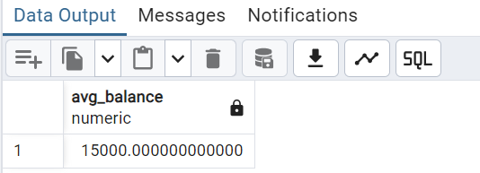



SELECT branch_name, COUNT(accno) AS number_of_accounts FROM ACCOUNT GROUP BY branch_name;

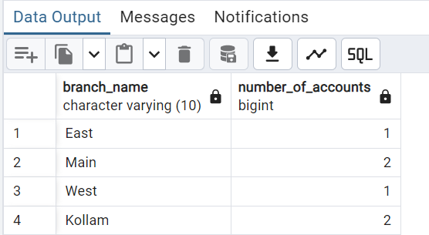



SELECT branch_name FROM ACCOUNT GROUP BY branch_name HAVING AVG(balance) > 12000;



SELECT DISTINCT customer_no FROM (SELECT customer_no FROM DEPOSITOR UNION SELECT customer_no FROM BORROWER) AS customers;

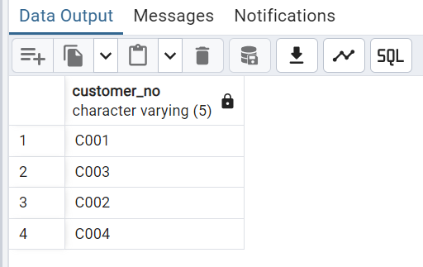



SELECT customer_no FROM DEPOSITOR INTERSECT SELECT customer_no FROM BORROWER;

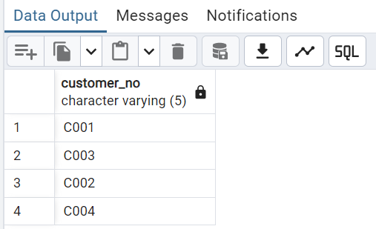



SELECT COUNT(DISTINCT branch_name) AS num_branches_with_loans FROM LOAN;



SELECT branch_name, AVG(amount) AS avg_loan_amount FROM LOAN GROUP BY branch_name;



SELECT customer_no FROM BORROWER GROUP BY customer_no HAVING COUNT(loan_number) > 1;

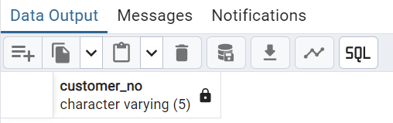



SELECT SUM(amount) AS total_loan_amount FROM LOAN;

